STRONG YOUR LOGIC BUILDING WITH STAR PATTERNS
Solve these 25 questions to master your logic and thinking ability.
It will help you think faster and build better logic for DSA questions.

Print the following Patterns:
- Print a Single Star (*) Code:

Explanation:
We only have to print one single *, so no need for loops here.

- Print Four Stars (****) Code:

Explanation:
Again, just a simple single print statement — no loops needed!

- Print n Stars on Same Line Code:
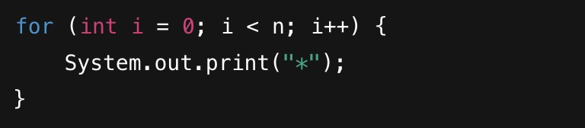
Explanation:
  - for (int i = 0; i < n; i++) → Loop from i = 0 to i = n-1.
  - Inside the loop, print * without newline using System.out.print("*");.
  - So all stars come in the same line.

- Print Square of Stars (n x n Stars) Code:
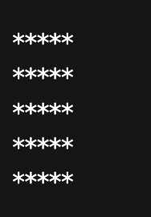
Code:
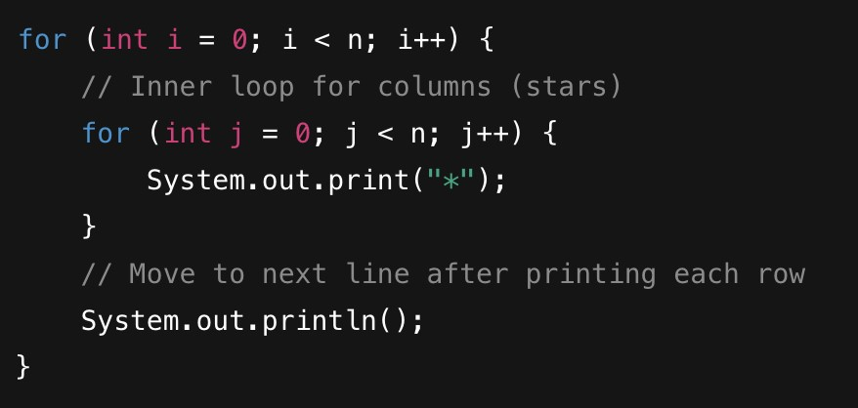
Explanation:
  - Outer loop → Runs n times to print n rows.
  - Inner loop → In each row, print n stars.
  - After each row, do System.out.println(); to move to the next line.

- Print an Increasing Triangle of Stars
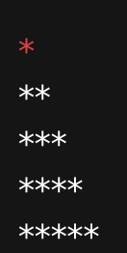
code:
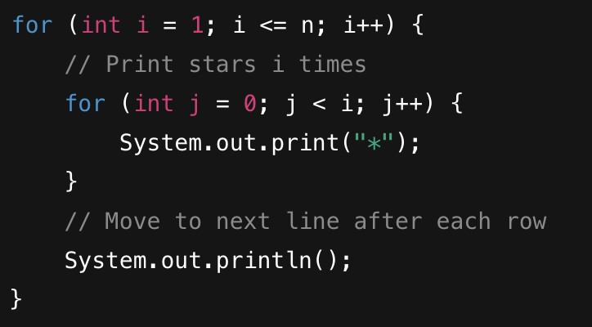
Explanation:
  - Outer loop runs from i = 1 to i = n.
  - In each row, print i stars.
  - After printing all stars in a row, move to the next line using System.out.println();.

- Print a Right-Aligned Triangle of Stars
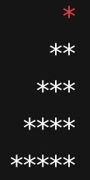
Code:
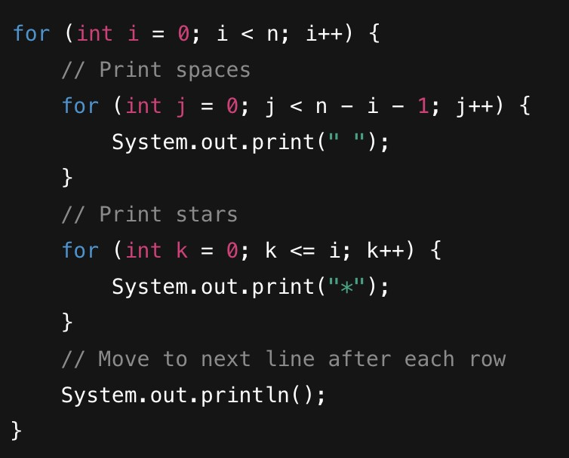

Explanation:
  - First inner loop: Print (n-i-1) spaces.
  - Second inner loop: Print (i+1) stars after spaces.
  - After printing spaces and stars for one row, use System.out.println(); to move to the next line.
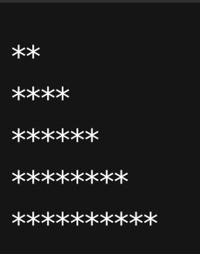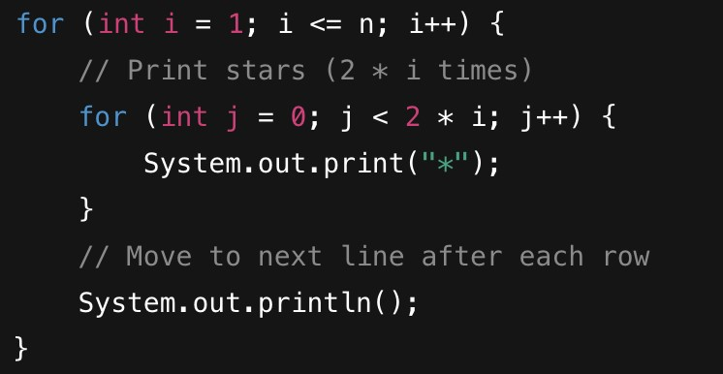

7.

Print

Stars

in

Even

Numbers

,
(2

,
4

6
,

8
,

10)

Code:

Explanation:

  - Outer loop runs from i = 1 to i = n.
  - In each row, print 2*i stars.
  - After printing stars for a row, move to the next line with System.out.println();.
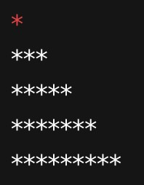

8.

Print

Stars

in

Odd

Numbers

(1
,

3
,

5
,

7
,

9)

Code:
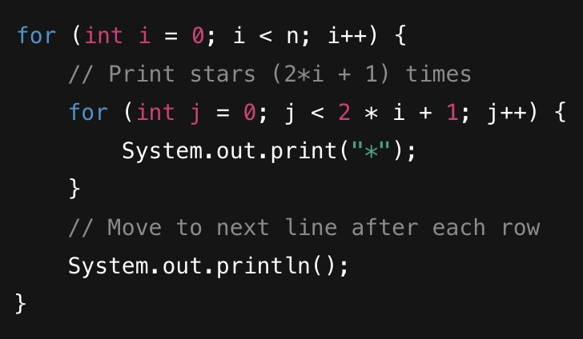
Explanation:
  - Outer loop runs from i = 0 to i = n-1.
  - For each row:
○ Number of stars = 2*i + 1 (always an odd number).
○ Think like for every i we need 2*i+1
  - After printing stars for the row, move to the next line with System.out.println();.

- Print a Centered Pyramid of Stars
Pattern:
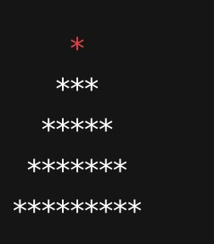
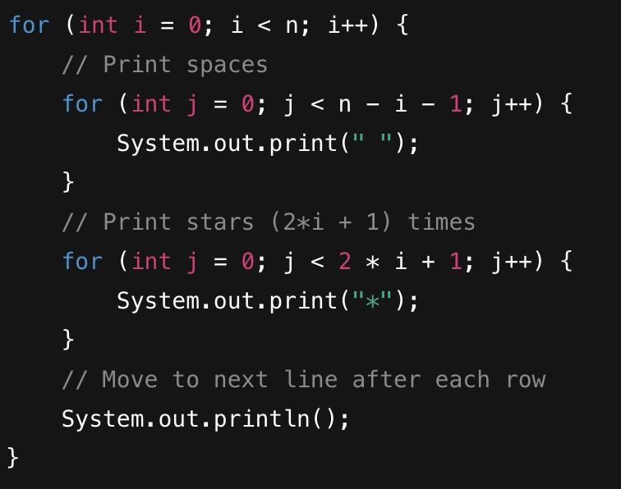
Explanation:
  - Outer loop runs from i = 0 to i = n-1.
  - First inner loop: Print (n-i-1) spaces to shift stars to the center.
  - Second inner loop: Print (2*i + 1) stars (1, 3, 5, 7, 9...).
  - After printing spaces + stars for one row, move to the next line with System.out.println();.

- Print Stars and Spaces Alternating (Stars and Blank Spaces)
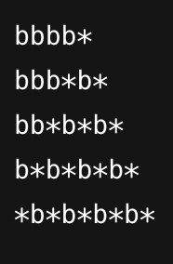
I have added b instead of space . Think like b is your blank space

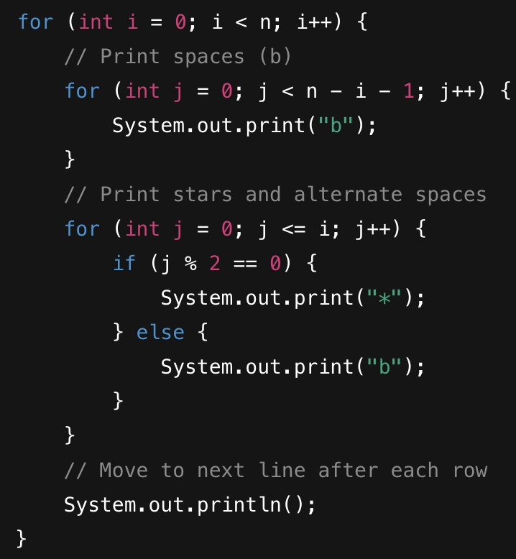.

Explanation:
- Outer loop runs from i = 0 to i = n-1.
- First inner loop: Print (n-i-1) spaces (b) to align stars correctly.
- Second inner loop: Alternate between printing stars (*) and blank spaces (b) using if (j % 2 == 0) to check for even and odd positions.
- After printing stars and spaces for one row, move to the next line with System.out.println();.

- Print Numbers in an Increasing Sequence (1, 12, 123, 1234, 12345)
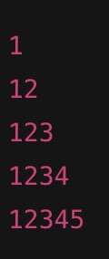
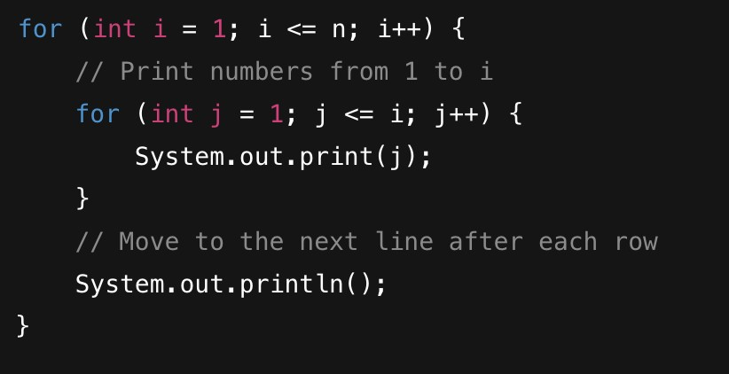
Explanation:
  - Outer loop runs from i = 1 to i = n.
  - Inner loop prints numbers starting from 1 up to i in each row.
  - After printing the numbers in each row, move to the next line with System.out.println();.

- Print Repeated Numbers per Row (Same Number Repeated)
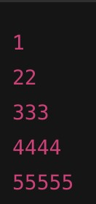
Code:
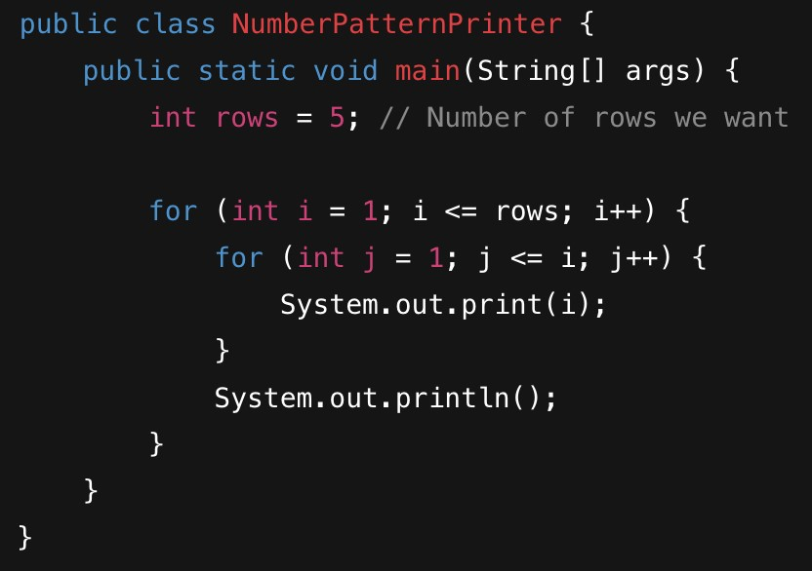
We have two for loops:
  - Outer loop runs for each row (from 1 to 5).
  - Inner loop prints the current row number (i) exactly i times.
  - After printing for one row, we move to the next line using System.out.println().

13.
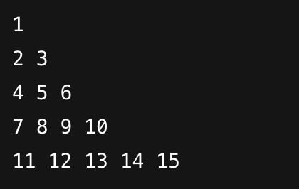

Code:
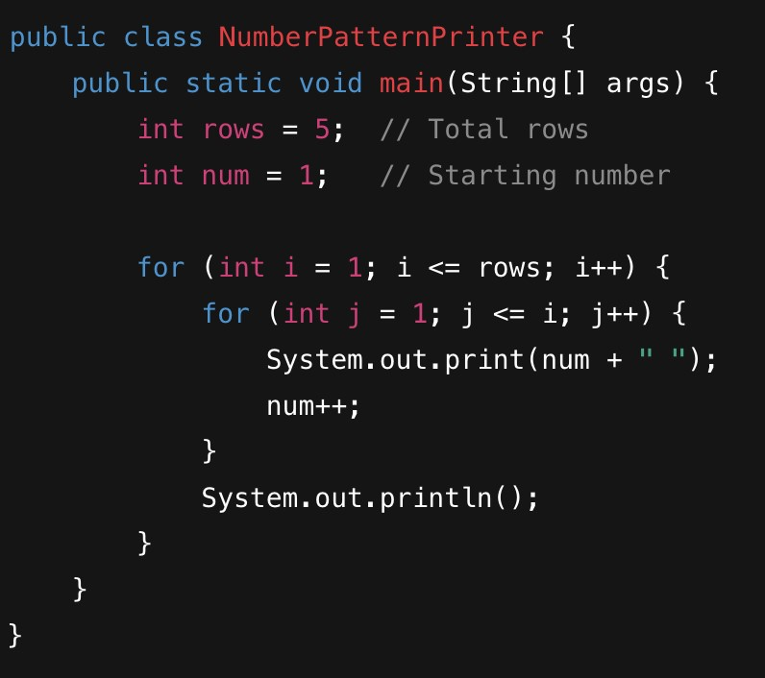
explanation:
  - Start from num = 1.
  - For each row i, print i numbers.
  - After each number, add a space.
  - After each row, go to the next line.
  - Keep incrementing num after printing.

14.
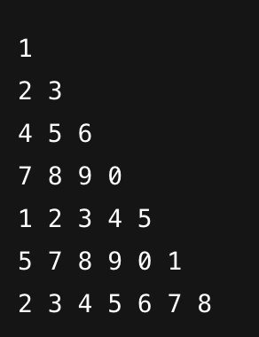
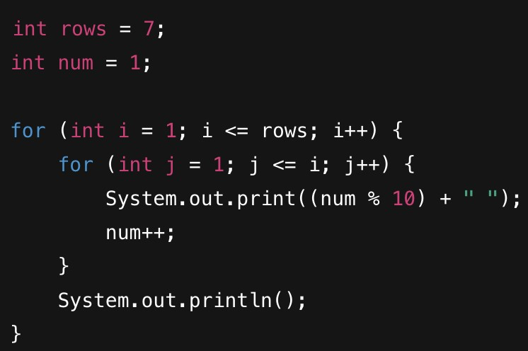
Explanation:
  - num starts at 1 and increases after every print.
  - num % 10 keeps only the last digit (wraps after 9 to 0).
  - Outer loop runs for each row.
  - Inner loop prints i numbers in row i.
  - After each row, move to the next line.

15.
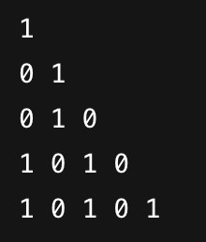
Explanation:
  - Loop runs for 5 rows.
  - Inner loop prints i values in row i.
  - The value to print is (i + j) % 2:
    - This alternates between 0 and 1 based on the sum of row and column indexes.
  - The pattern starts with 1 and alternates accordingly.
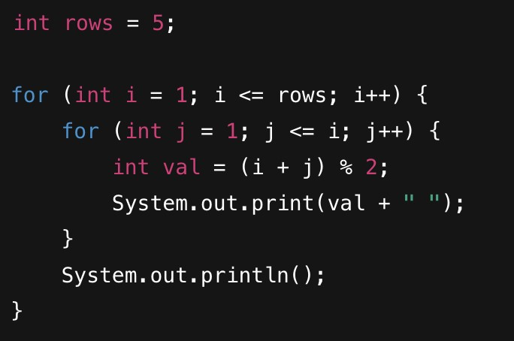

16
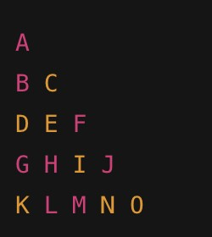
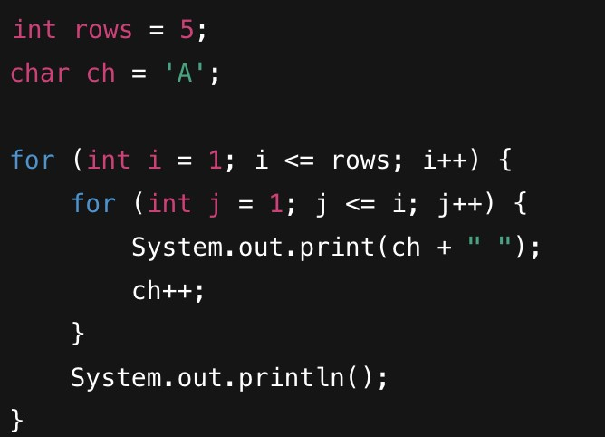
Explanation:
  - char ch = 'A' initializes the starting alphabet.
  - Outer loop runs from 1 to 5 (for 5 rows).
  - Inner loop runs i times for row i.
  - Each character is printed and then incremented (ch++).
  - Output continues alphabetically from A to O.

17
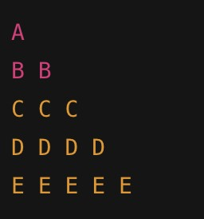
Code:
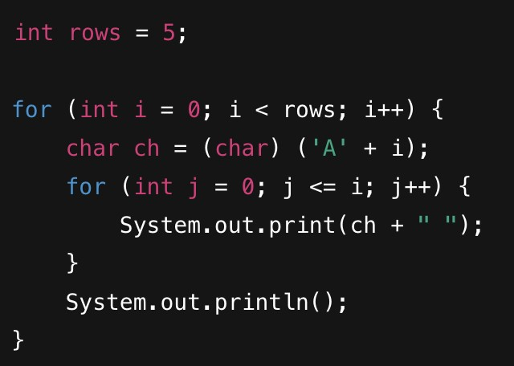
Explanation:
  - rows = 5 → pattern has 5 rows.
  - Outer loop runs from 0 to 4.
  - In each row, calculate the character as 'A' + i:
    - Row 0 → A, Row 1 → B, ..., Row 4 → E.
  - Inner loop prints the same character i+1 times. ● System.out.println() moves to next line.

18.
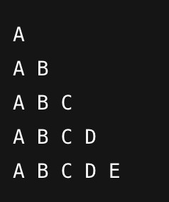
Code:
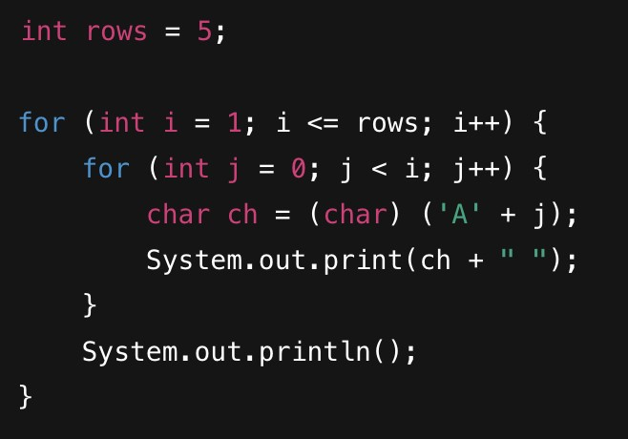
Explanation:
  - rows = 5 → 5 rows in the pattern.
  - Outer loop runs from 1 to 5 (row count).
  - Inner loop runs j < i to print increasing letters in each row.
  - 'A' + j gives the next character (A, B, C, ...).
  - Characters always start from 'A' in each row.
  - System.out.println() moves to the next line.

19.
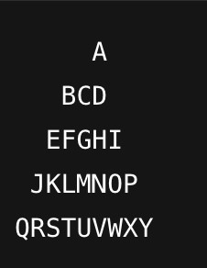
Code:
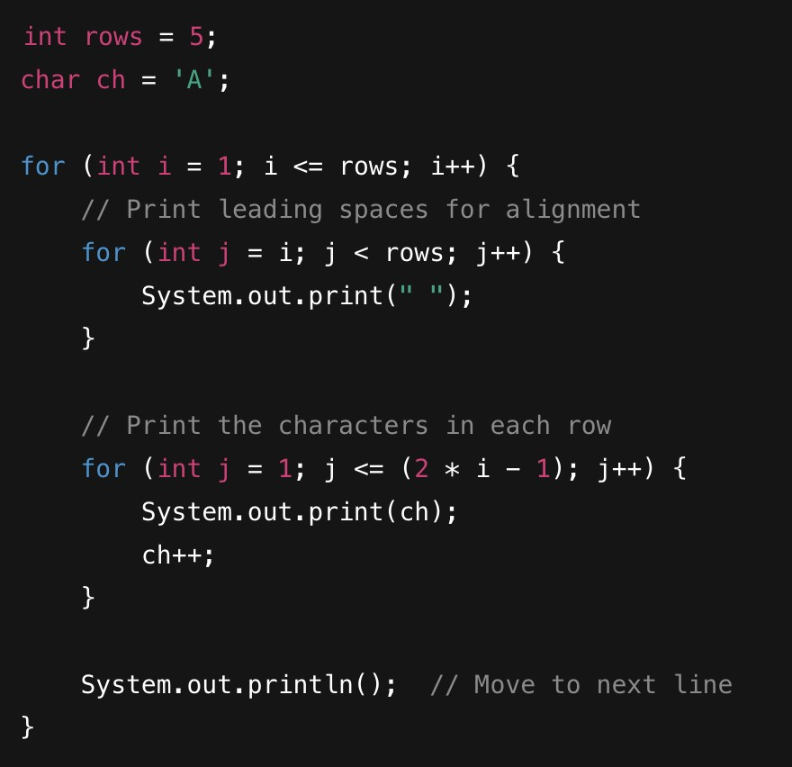

Explanation:
  - rows = 5: Defines the number of rows.
  - char ch = 'A': Start from character 'A'.
  - Outer loop (i) runs for each row.
  - Leading spaces: Inner loop prints spaces to align the characters in a pyramid shape.
  - Print characters: The second inner loop prints 2 * i - 1 characters for row i
(odd number of characters).
  - After printing, increment the character (ch++) and move to the next line using System.out.println().

20.
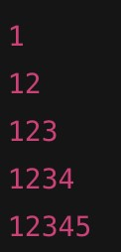
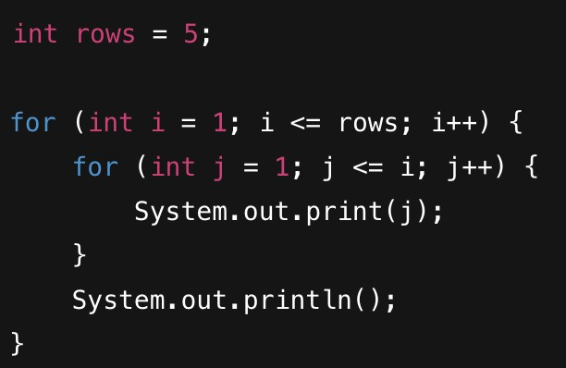
🧠 Explanation:
  - rows = 5: Defines the number of rows.
  - Outer loop (i) runs from 1 to 5 (for 5 rows).
  - Inner loop (j) prints numbers from 1 to i for each row.
  - System.out.println() moves to the next line after printing each row.

21.
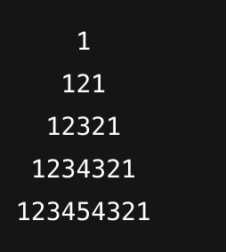
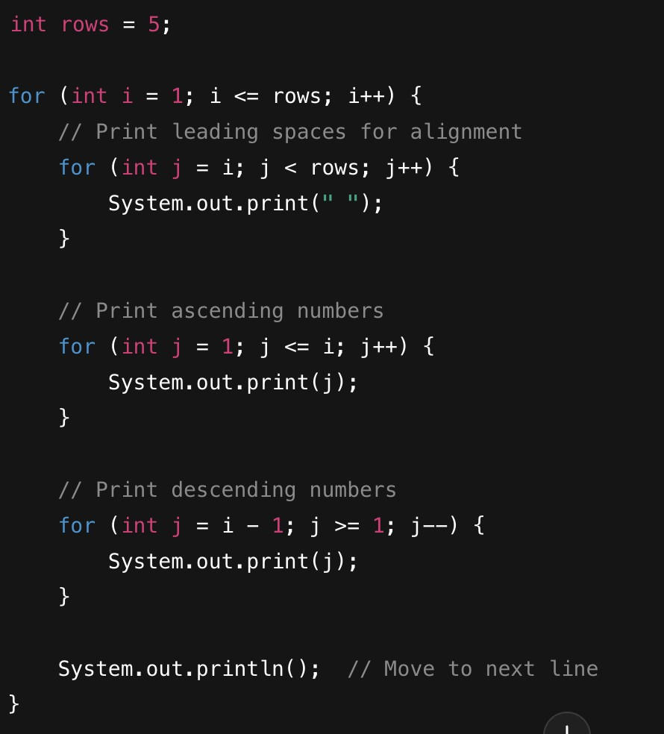
Explanation:
  - rows = 5: Defines the number of rows.
  - Outer loop (i) runs from 1 to 5 (for 5 rows).
  - Leading spaces: Inner loop prints spaces for alignment to form the pyramid shape.
  - Ascending numbers: Print numbers from 1 to i.
  - Descending numbers: Print numbers from i-1 down to 1.
  - System.out.println() moves to the next line after each row.

22.
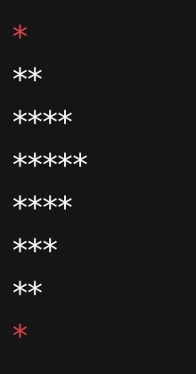
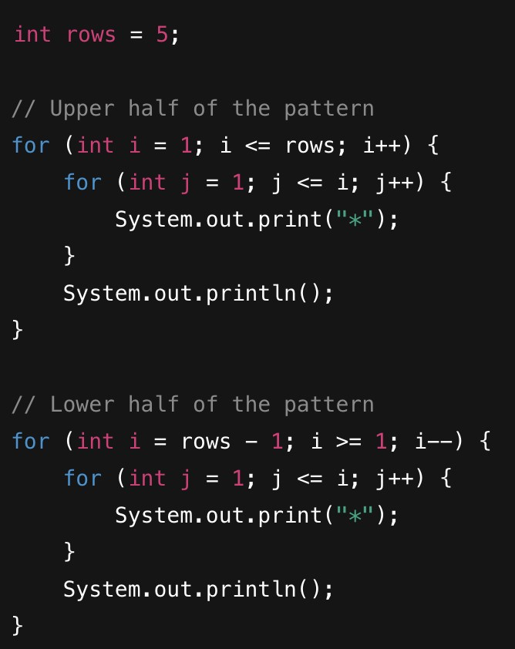
Explanation:
  - rows = 5: Defines the number of rows for the upper half of the pattern.
  - The first loop prints the upper part of the pattern, starting from 1 star up to rows stars.
  - The second loop prints the lower half of the pattern, starting from rows-1 stars down to 1 star.
  - System.out.println() moves to the next line after printing each row.

23.
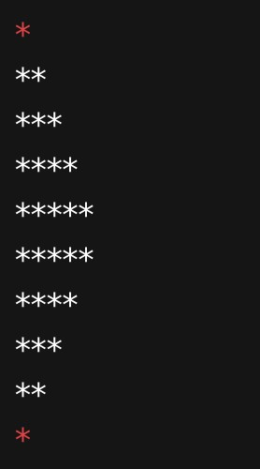
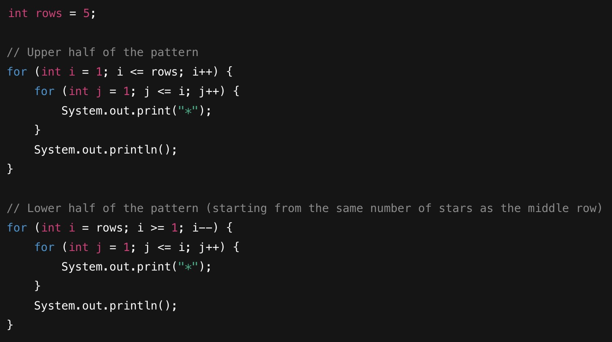
Explanation:
  - rows = 5: Defines the number of rows for the first half of the pattern.
  - The first loop prints the upper part of the pattern, from 1 star to rows stars.
  - The second loop prints the lower half, starting from rows stars down to 1 star.
  - System.out.println() moves to the next line after printing each row.

24
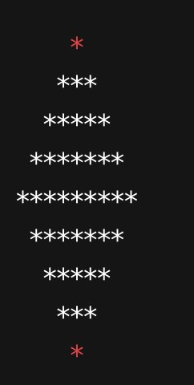
Code:
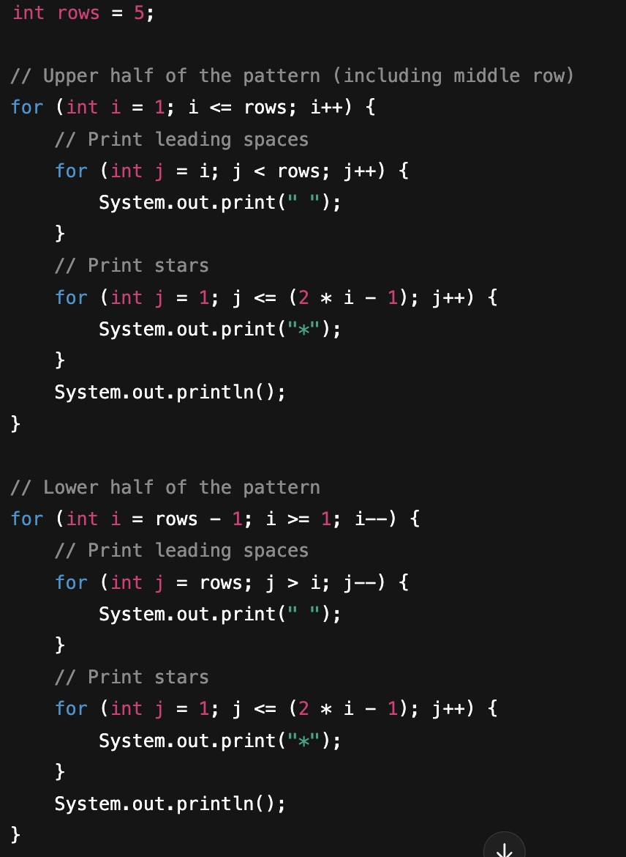

Explanation:
  - rows = 5: Defines the number of rows for the upper part of the pattern (excluding the middle row).
  - The first loop prints the upper half of the pattern:
    - For each row, print the leading spaces first, then the stars (2 * i - 1 stars for row i).
  - The second loop prints the lower half of the pattern:
    - Similar to the first loop but starts from rows - 1 and prints fewer stars as the row number decreases.
  - System.out.println() moves to the next line after printing each row.

25.
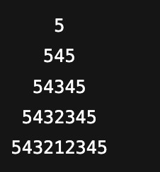
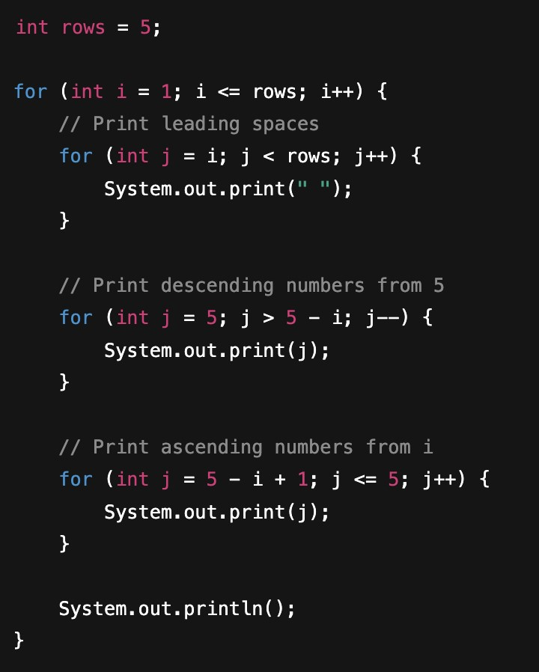
Explanation:
  - rows = 5: Defines the number of rows.
  - The first loop prints the leading spaces to center-align the pattern.
  - The second loop prints numbers in descending order, starting from 5 and decreasing until the appropriate number for each row.
  - The third loop prints numbers in ascending order, starting from the number after the descending ones.
  - System.out.println() moves to the next line after each row.

